

**Assignment-Module-III**

**Qu Mingxuan**

**Xiao Sa**

**Song Yang**

# Introduction

LTspice is an easy to used but yet very powerful spice simulator mainly used for simulation or electronic circuits. The underlying equations used in electrical circuits have the same form as many other physical system such as magnetic, thermal, mechanical. This gives an opportunity to utilize the simulator to perform more complicated tasks such as coupled physical simulations in a very efficient way that cannot be achieved with full FEM simulations. In this assignment three different systems should be modeled. First electrical coupling from a switched DC regulator to a sensitive analog signal will be investigated and then two electron thermal systems.

# TASK-I. Transient heating of a MOSFET under over current conditions.

## Task guidance

The task is to simulate the self heating of a transistor that is used in an invert circuit turned on at the nominal grid frequency 50Hz. Set up a simulation using the transistor GS66516B (GaN systems) to switch at 50% duty cycle at 50Hz. The transistor should drive a load of 3 Ohm from 100V source. The transistor is connected to a heat sink with the characteristic as in the figure. The heat sink model is based in the a thin isolation material and a following heat sink.

For accurate modeling of the heating of semiconductor devices both temperature dependent transistor model should be used but also a realistic thermal model off the transistor and thermal design.

## Experimental circuit

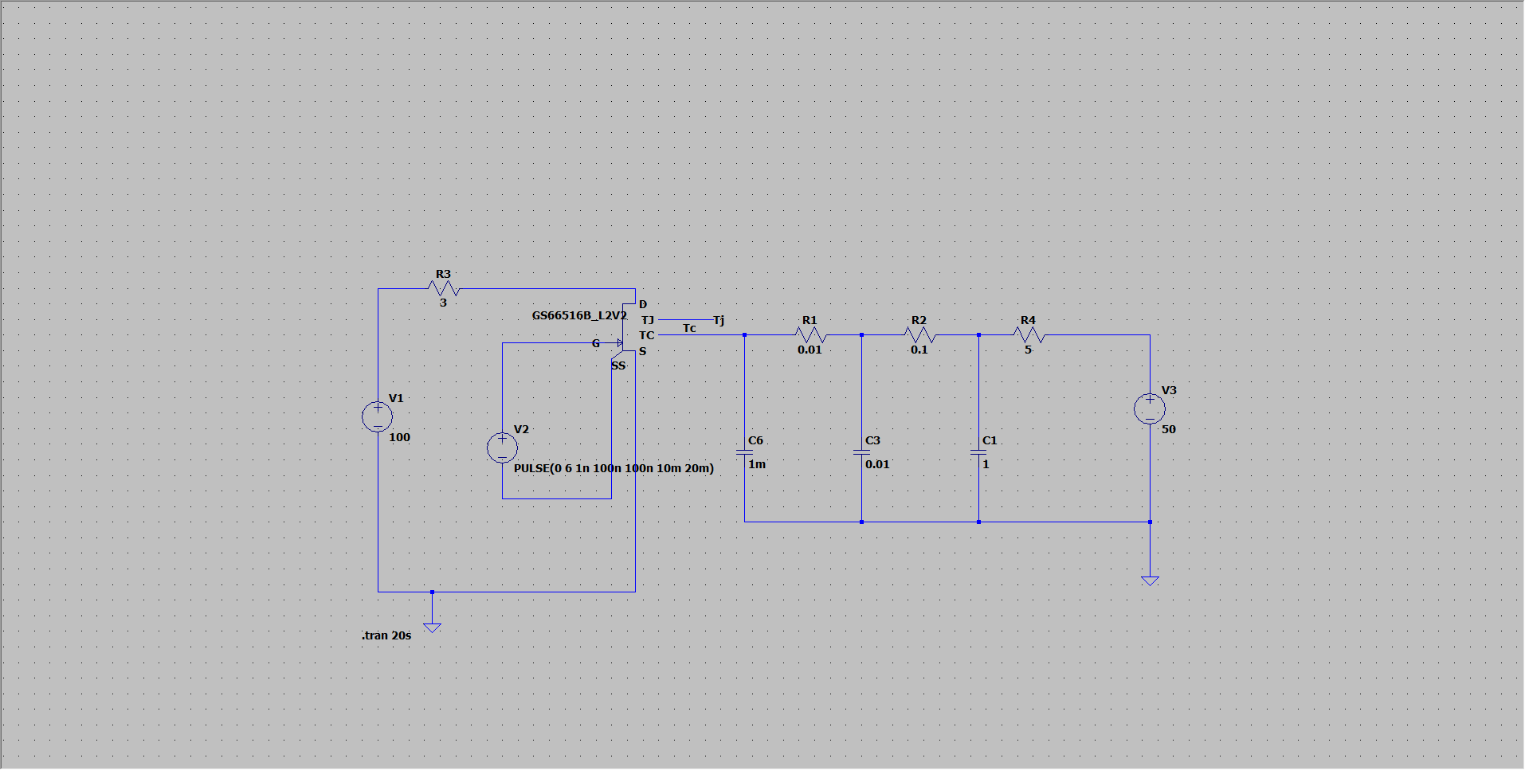

Figure1 circuit overview

## Conclusion

### (1) Determine how fast the circuit will take before over heating.

After many simulations, over heating time are effected by Resistor4 and Capacitor1 changing.

Capacitor1:

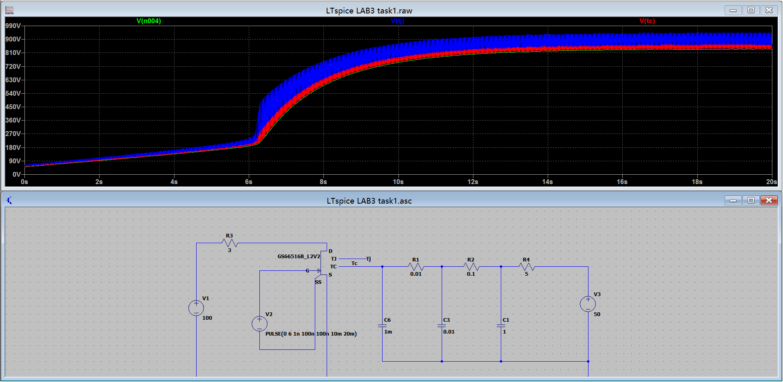

Figure2 R4=5Ω C1=1F

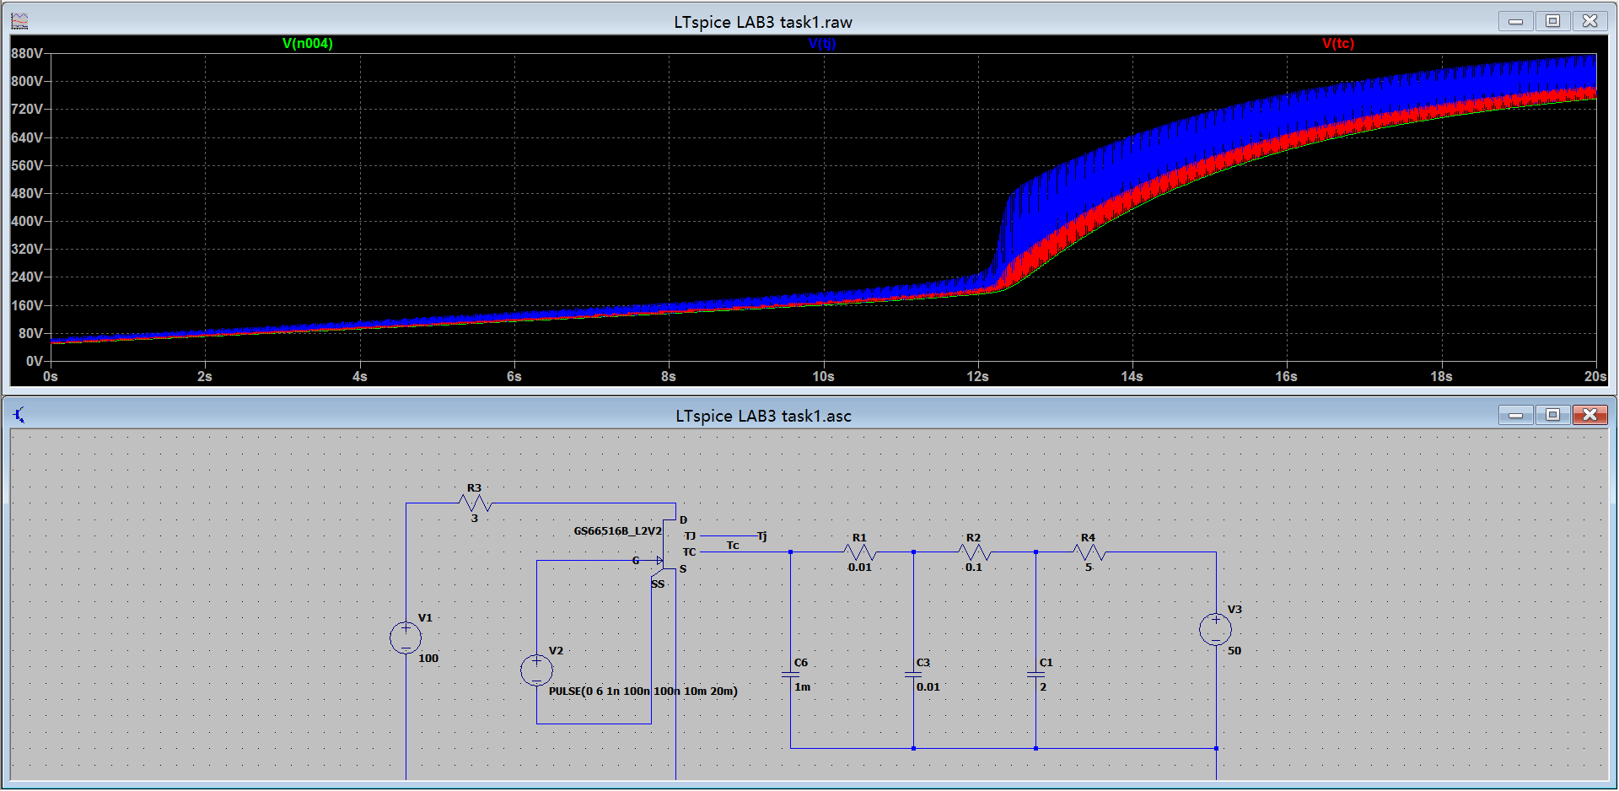

Figure3 R4=5Ω C1=2F

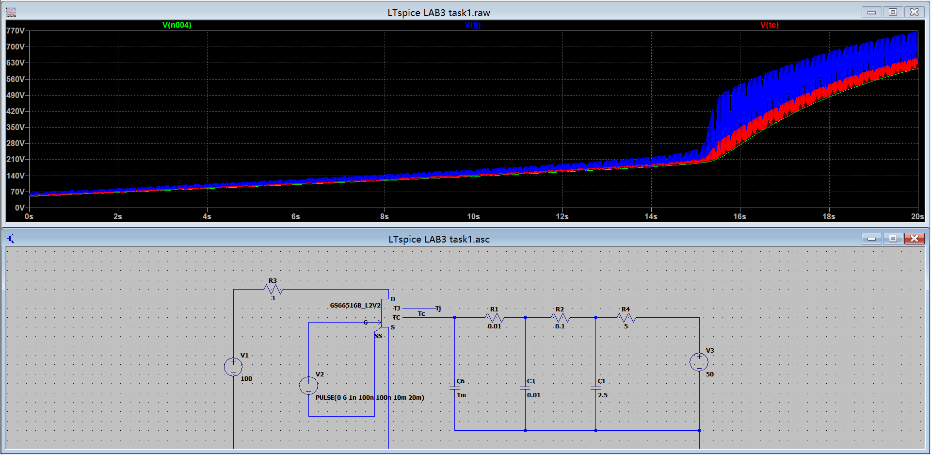

Figure4 R4=5Ω C1=2.5F

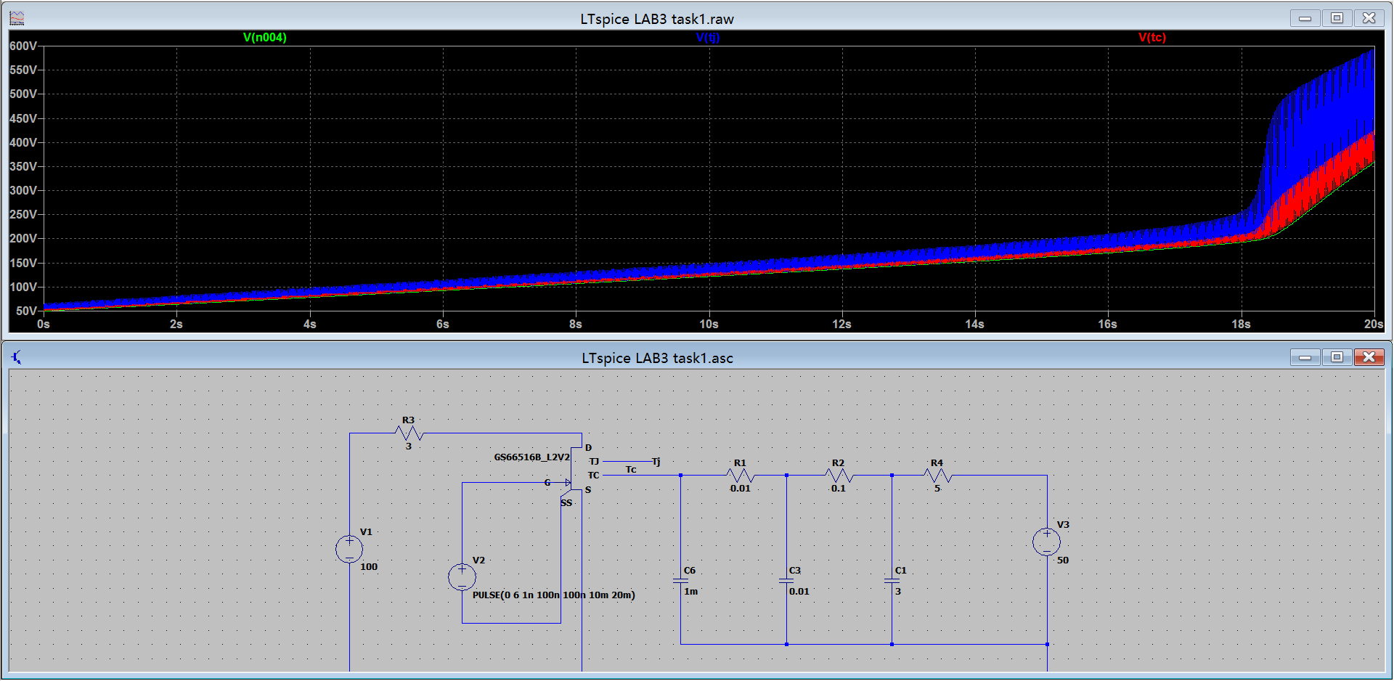

Figure5 R4=5Ω C1=3F

According to the simulation, we can sum up that the capacitance rising can delay the over heating time, striving for a longer time for the circuit to operate effectively.

Resistor1:

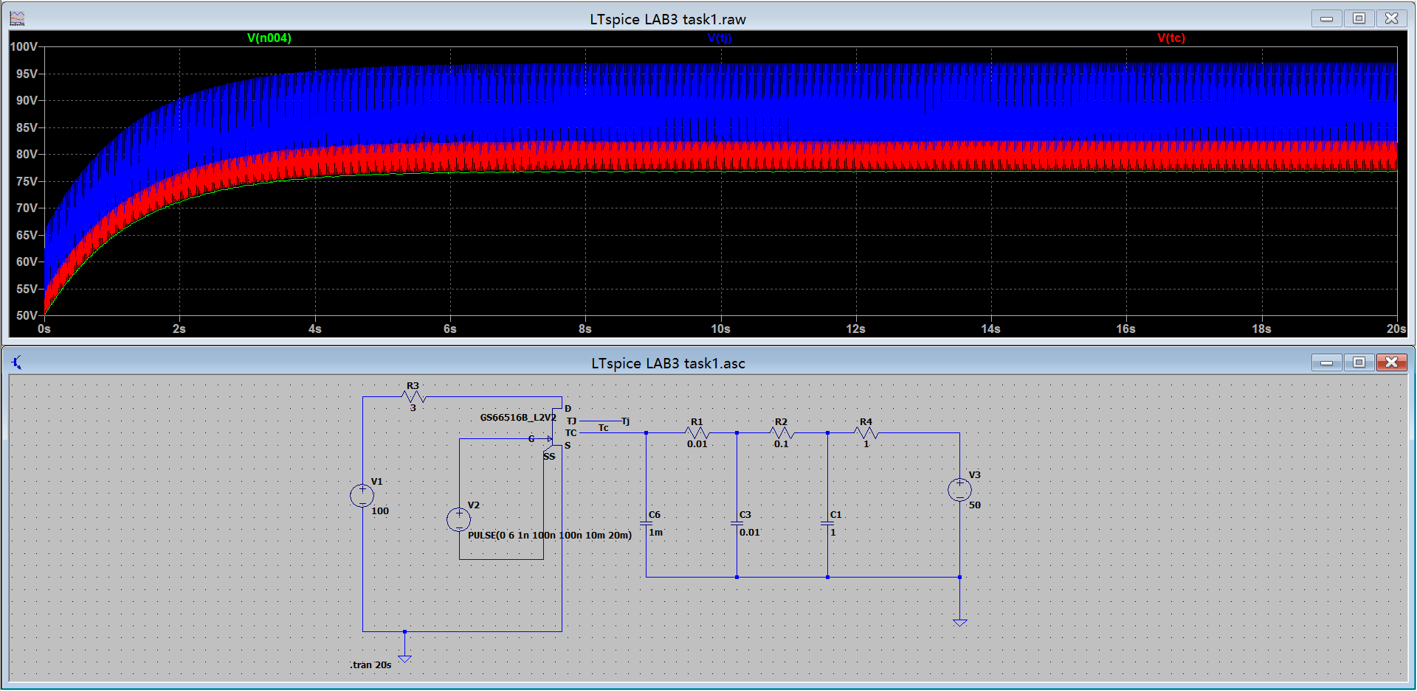

Figure6 R4=1Ω C1=1F

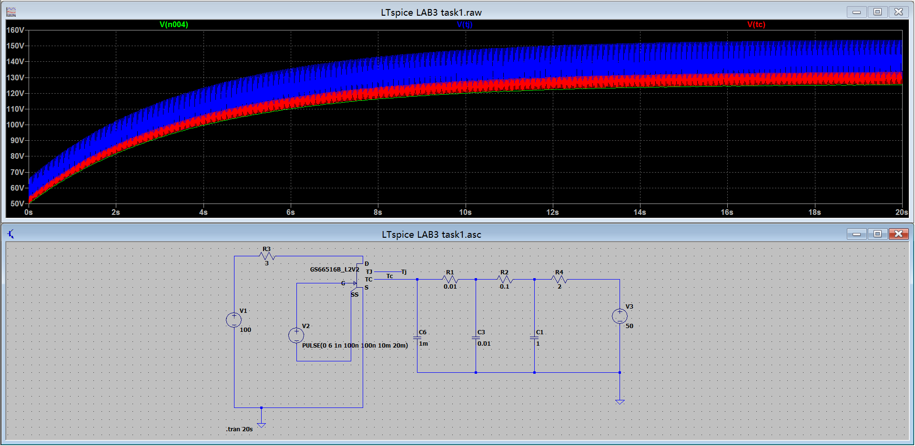

Figure7 R4=2Ω C1=1F

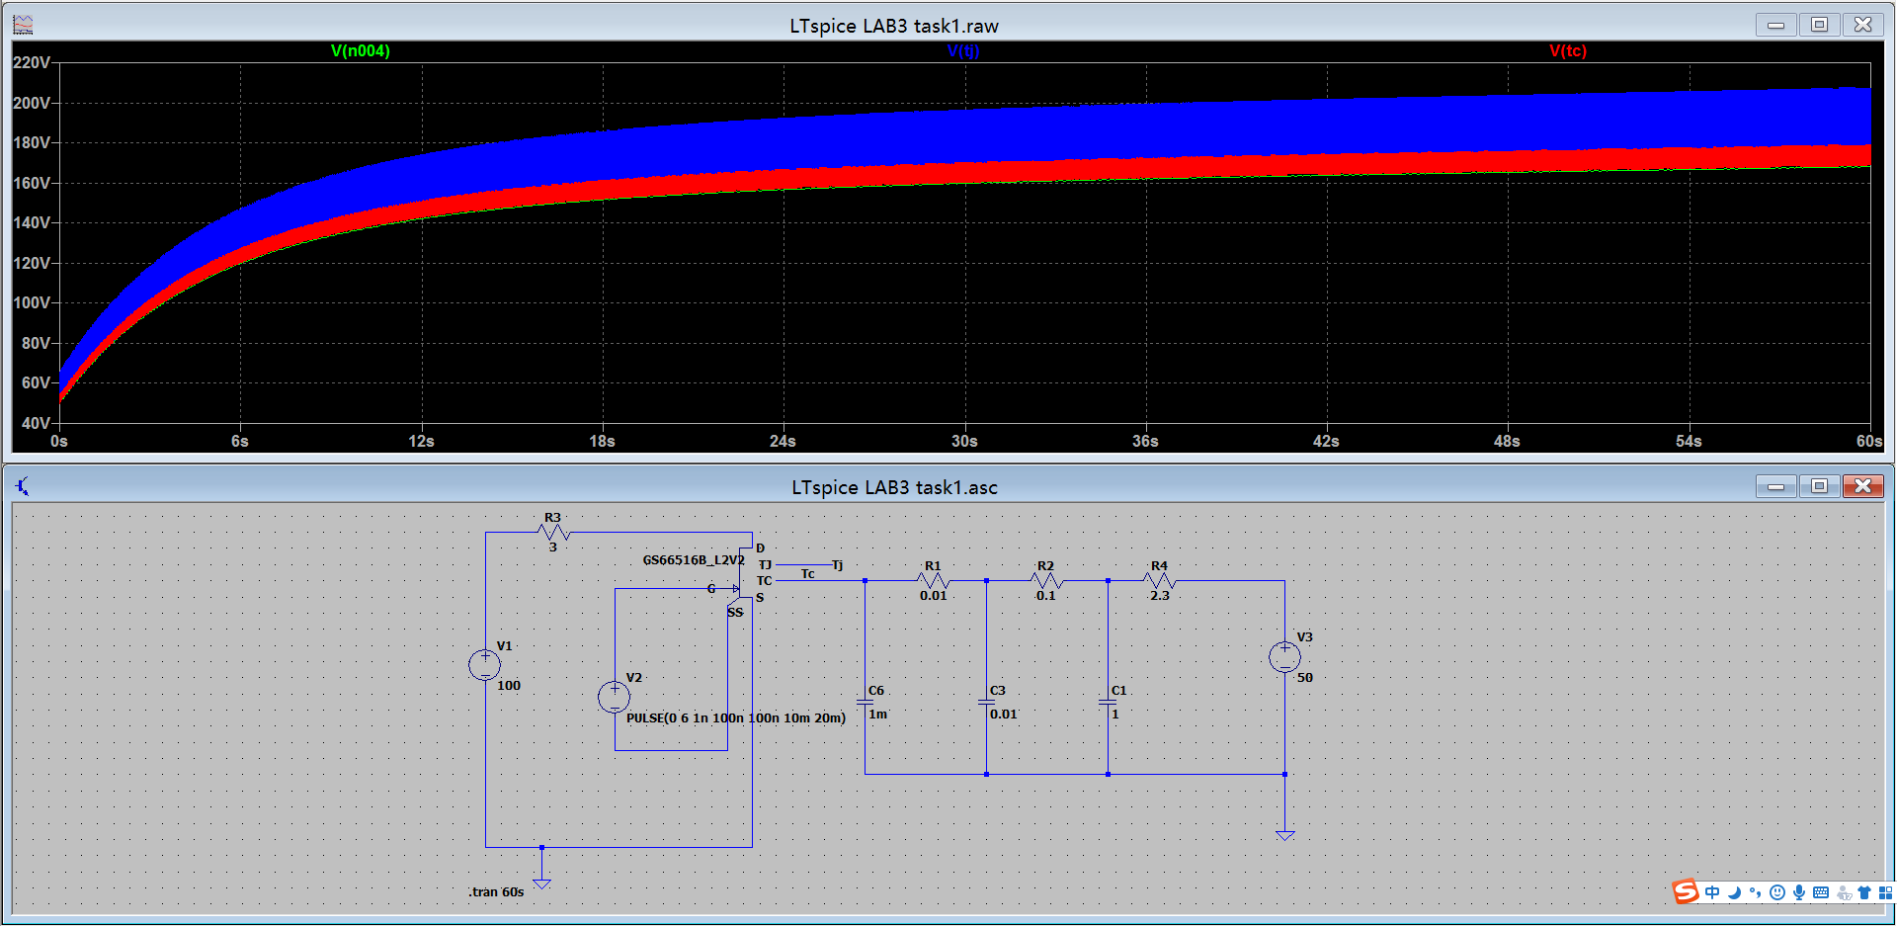

Figure8 R4=2.3Ω C1=1F

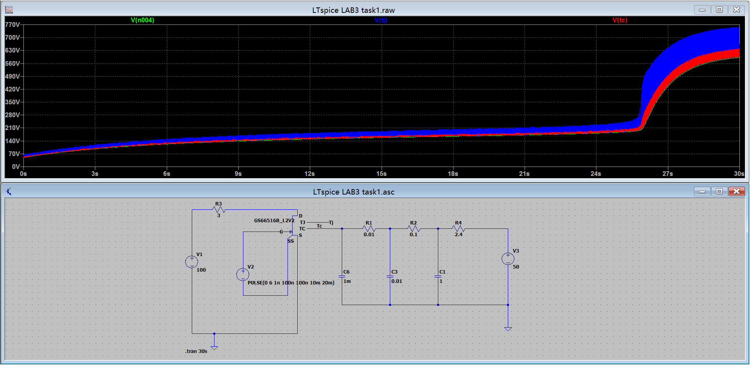

Figure9 R4=2.4Ω C1=1F

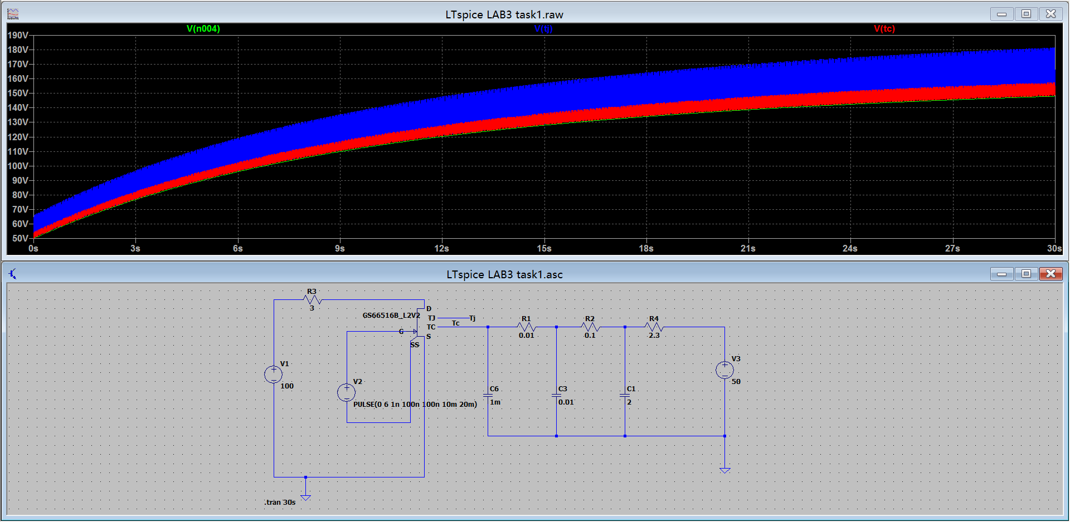

Figure10 R4=2.3Ω C1=2F

At first, we found the resistance critical value. When we set the resistance more than 2.3Ω, the circuit will fail with a dramatic rise in simulation windows and not affected by capacitance. And then we focus on effective parts which resistance lower than critical value. It shows that the higher resistor4 value we put, the more working time we get.

### What are the important factors in the thermal design.

Voltage input, resistance and capacitance are the important factors in the thermal design. The effect of R and C were covered before. The voltage input also not hard to understand, because it is the energy that the circuit needs to withstand when it is running. More energy supply naturally causes the circuit to be more prone to heat. Just like we increase weight by 20kg to jogging the same distance with current weight, which one makes it easier for us to sweat?

### Calculate the dominant thermal time constant of the design.

The thermal time constant is the time which the time taken to reach 63.2% of the maximum temperature. So we compare several groups data and get the result is R4×C1.

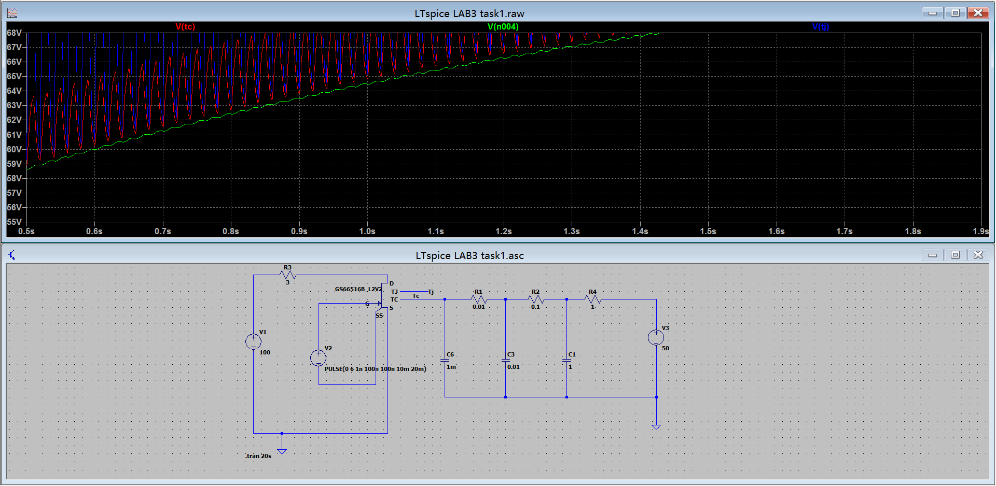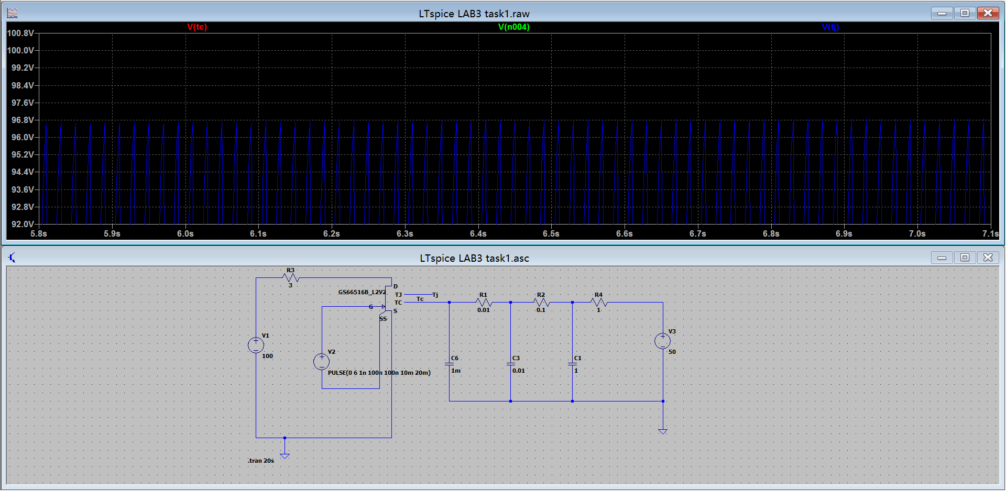

Figure11 R4=1Ω C1=1F

The maximum temperature is around 96.5℃, we times it with 63.2%, the time located around 1s, equal to R4×C1.

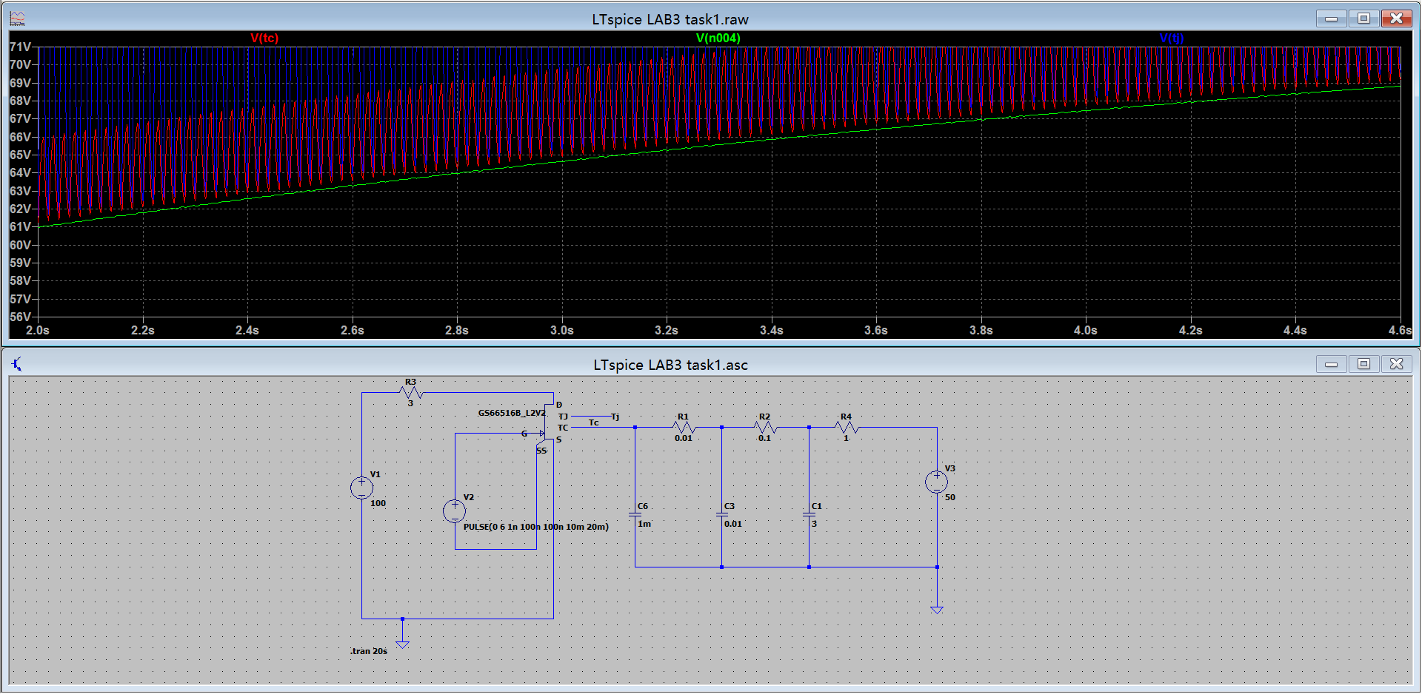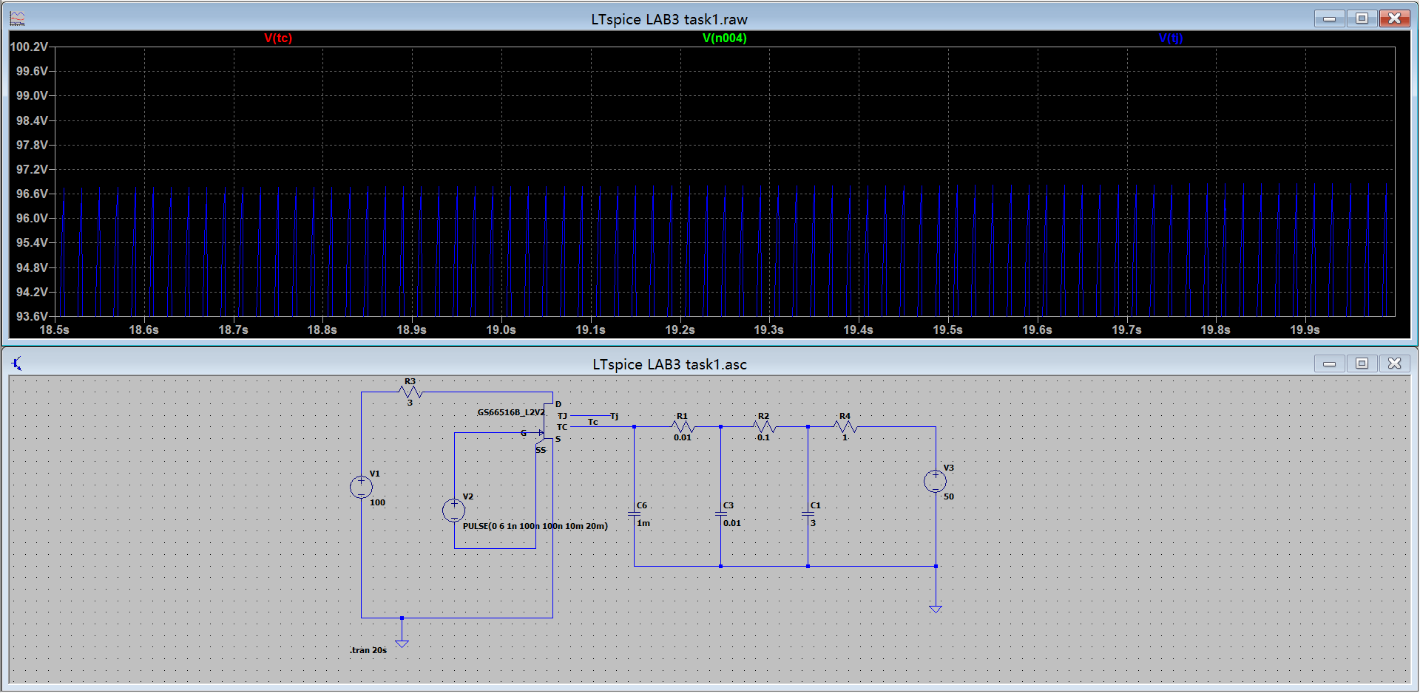

Figure12 R4=1Ω C1=3F

The maximum temperature is around 96.8℃, we times it with 63.2%, the time located around 3s, equal to R4×C1.

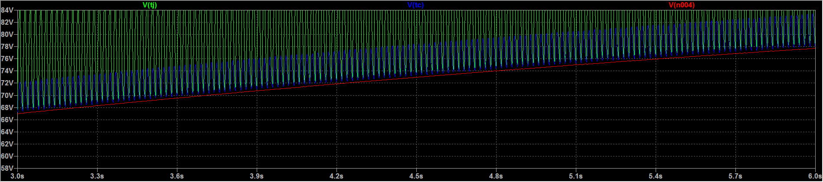

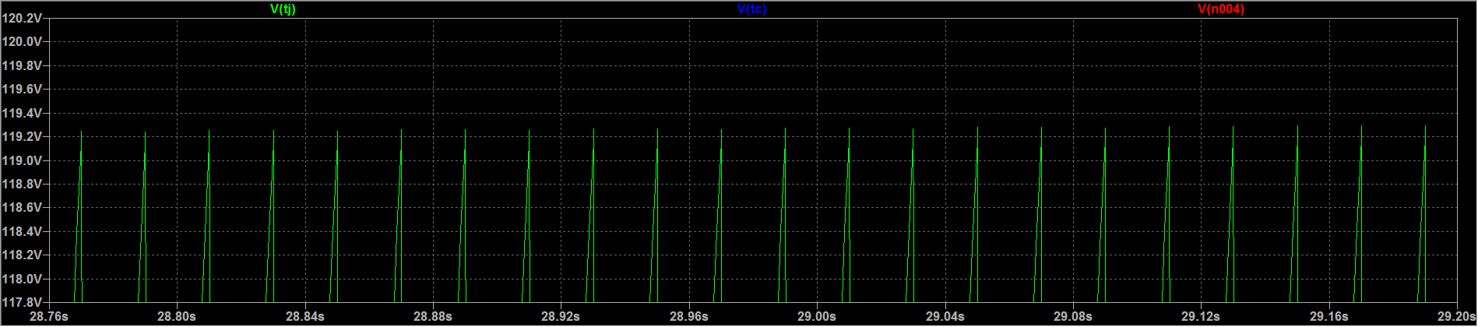

Figure13 R4=1.5Ω C1=3F

The maximum temperature is around 119.3℃, we times it with 63.2%, the time located around 4.5s, equal to R4×C1.

### Discuss overall methods to ensure fail safe operation of an inverter like this.



**B**

**A**

**C**

Figure14 temperature sensor setting point

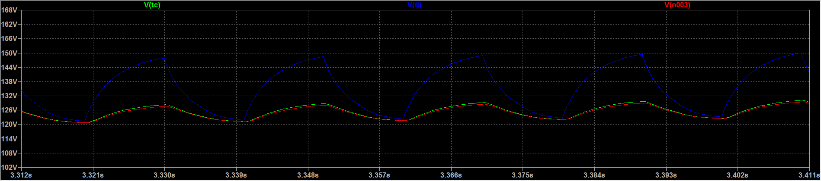

Figure15 point A and B

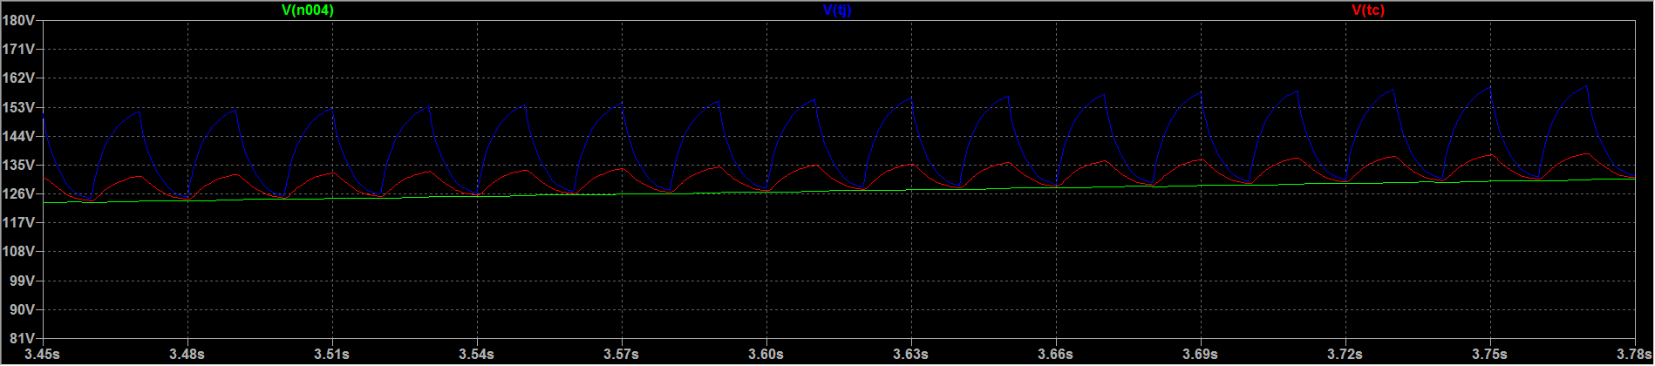

Figure16 point C

We can put temperature sensors in point A, B or C.

In point A we measure the Case temperature. According to the data sheet file, the junction temperature is 150 degrees. At that time, case temperature at around 129 degrees. So we can put a temperature sensor in that point and make sure working temperature lower than 125 degrees, although the Tc is a fluctuating value.

For the point B, it all most overlapping with A point value, so i think probably it can place the same temperature sensor at point B.

In point C we measure the temperature is 30 degrees below the maximum temperature. So if temperature lower than 120 degrees, it can safety working.